Path Mapper User’s Guide

## Document Number 20-1615

## October 13, 2016

## Introduction

Trillium’s series of mapping payloads are able to autonomously capture high resolution images along a predefined path. The system consists of the following primary components:

1. **Gimbal** The gimbal points the camera at the desired imaging location using an onboard GPS/INS.
2. **Camera** The camera or cameras capture images at desired locations.
3. **Mapper Computer** The mapper computer feeds imaging locations to the gimbal, captures images for the camera, and stores images and metadata from the gimbal for post processing.

There are two system architectures depending on where the Path Mapper application resides:

#### Unmanned

In the unmanned architecture shown in Figure 1, the Path Mapper application is executed on an onboard computer which is controlled by an operator over a datalink. This architecture is used for unmanned applications since operator control can be accomplished over a low bandwidth datalink.



Figure 1 - Unmanned System Architecture

#### Manned

In the manned architecture shown in Figure 2, the Path Mapper application is executed on the operator’s computer and requires a GigE link to the camera.



Figure 2 - Manned System Architecture

## Input Files

Path Mapper requires two input files: a file detailing the location of the imaging path and a file detailing the mapping parameters. The settings file should be placed in the same directory as the Path Mapper application. The location of the path file is specified in the settings file which defaults to the same directory as the settings file. Example files are attached to this document and their format is detailed below.

#### Path File

The path file consists of a number of latitude, longitude, altitude points that collectively represent the desired imaging path. The path file format is a .csv file with a single longitude, latitude, altitude on each line. Latitude and longitude coordinates should be in decimal form and altitude should be in meters MSL. The following rules of thumb should be observed when making a path file:

* A path file must have at least two points.
* Points must be in consecutive order spatially i.e. a path must never backtrack on itself.
* The system will linearly interpolate intermediate imaging locations between two successive points, so the point density should be driven by the path curvature.
* In general, point density should be as sparse as possible. Specifically, any two successive points should be larger than the step distance which is defined by the angular step distance in the mapping parameters and the flight AGL altitude.

In order to visualize a path, install Trillium’s SkyLink user interface and place the path file into C:\Trillium\PathData\. Upon startup, SkyLink will show the path on the map which is a quick method to verify the path location and is useful for visualization during mapping.

SkyLink can be used to create a path file using the following procedure:

1. Open C:\Trillium\GeoPoints.csv and delete all the lines that contain geopoints which are those that don’t start with a # character. Close the file.
2. Open SkyLink and ensure imagery and elevation data have been downloaded in the area of the path. Create a series of geopoints on the desired path by right clicking on the map and selecting Add Geopoint Here. Close SkyLink.
3. Open GeoPoints.csv with Excel and reformat to be a path file by deleting rows that start with #, deleting the column with the geopoint names, and swapping the Lat and Long columns. Save into folder C:\Trillium\PathData\.
4. Open SkyLink again to visualize the path.

#### Settings File

The path mapper settings file controls a number of inputs to the system as defined below.

|  |  |
| --- | --- |
| **Parameter** | **Description** |
| PathData | The location of the path data or a folder containing path data files |
| VDatum | Vertical datum used for altitudes in the point file, currently unused. |
| StepAngle_Deg | The forward step angle in degrees. Use this parameter to define the image overlap; for example, if a camera has a 10 degree vertical FOV and a 25% image overlap is desired, the vertical step should be 7.5 degrees. |
| StartDist_M | Path tracking will begin when you are within this many meters of a path. |
| Gain_MaxVel  Gain_MaxAccel  Gain_Tracking  Gain_CloseThresh  Gain_StareThresh  Gain_StareTime | Gains that control the gimbal’s step-stare behavior. Do not modify without discussion with Trillium. |
| Cam_ExposureAutoMax | The maximum allowed integration time in milliseconds |
| Cam_ExposureAutoTarget | The target image grey level in percent |
| Cam_ExposureAutoRate | The AGC filter speed, 0 to 100 with 100 being the fastest |
| Cam_ExposureAutoOutliers | The percentage of outlier pixels to ignore during AGC calculations |
| Cam_Gamma | Image gamma |
| Cam_DSPSubregionTop  Cam_DSPSubregionLeft  Cam_DSPSubregionBottom  Cam_DSPSubregionRight | The subset of pixels used for AGC calculations |

## Operation

#### Manned Operation

Take the following steps to setup a manned system:

1. Ensure the operator computer is running Windows 7.
2. Set the operator computer with an automatic IP address or a static IP address in the 169.254.X.X block with a subnet mask of 255.255.0.0.
3. Ensure Jumbo Frames are enabled on the computer’s network adaptor.
4. Ensure the focus calibration coefficients for the camera+lens are entered into PathMapperSettings.txt
5. Ensure the desired path is located in the directory indicated by PathMapperSettings.txt.

To operate the system:

1. Start SkyLink which should automatically find the gimbal on 169.254.87.45. Ensure the gimbal has successfully acquired GPS; the gimbal’s location will be shown on the top left of the video window. Click “Follow Gimbal” at the bottom of the map window to keep the map centered on the gimbal’s location.
2. Start the PathMapper application which will launch a command line window, see below for command line options. The application should automatically find the gimbal and the camera.
3. The system will start mapping once the gimbal is within the distance specified by StartDist_M. The aircraft should fly directly over the path for optimum results; the gimbal will image the path even if the aircraft is off course as long as the gimbal doesn’t exceed its mechanical limits.
4. Path Mapper will start listing various diagnostic data including the number of images taken and the image FPS. Images and metadata will be saved to C:\Trillium\PathMapper\ along with a copy of the settings file.
5. To stop mapping, close the Path Mapper window.

Command line operations include the following, note the double dash:

--pathData=[file path]

Specifies a CSV file with path data points, or a directory of CSV files with path data points. Defaults to current directory.

--outputDir=[output directory]

The directory to save images to. Defaults to C:/Trillium/PathMapper.

--pathSettings=[PathMapper settings file]

The PathMapper settings file that outlines specific PathMapper parameters. Defaults to ./PathMapperSettings.txt.

--cameraIp=[Camera's IP address]

The IP address of the camera. Defaults to auto discover the camera.

--frameRate=[Capture rate Hz]

If set, the application will capture images at the given interval regardless of gimbal state, this is mainly for testing. Set to -1 to disable. Defaults to disabled.

--? --help

Print available arguments.

#### Unmanned Operation

Take the following steps to setup an unmanned system:

1. For optimum frame rate performance, ensure the external hard drive is formatted to the Linus EXT4 file format.
2. Verify the focus calibration coefficients for the camera+lens are entered into PathMapperSettings.txt
3. Place the path file and settings file onto the external hard drive, then plug the hard drive into the mapping computer.

To operate the system:

1. If an Ethernet or serial connection to the gimbal is available, start SkyLink which should automatically find the gimbal. Ensure the gimbal has successfully acquired GPS; the gimbal’s location will be shown on the top left of the video window. Click “Follow Gimbal” at the bottom of the map window to keep the map centered on the gimbal’s location.
2. Log into the mapping computer using Putty or a similar console program. If connecting over Ethernet, the mapping computer IP address will be 169.254.87.46. Credentials are:

user: pathmapper

pw: pathmapper

If connecting over serial directly the terminal expects 115200 baud.

1. To change settings in the path settings file, use the command:

path config

Note that this will only modify a settings file that is located in the same directory as the path mapper application and will not modify the settings file on a hard drive. Because of this, its recommended to use the settings file on the Atlas computer so that variables can be changed in flight.

1. Start PathMapper by typing the following, see below for command line options:

path start; path log

1. The system will start mapping once the gimbal is within the distance specified by StartDist_M. The aircraft should fly directly over the path for optimum results; the gimbal will image the path even if the aircraft is off course as long as the gimbal doesn’t exceed its mechanical limits.
2. Path Mapper will start listing various diagnostic data including the number of images taken and the image FPS. Images and metadata will be saved onto the external hard drive. The hard drive should get mounted under something like /home/media/5949-E4F4.
3. To stop mapping, press CTRL+C, then type:

path stop

Command line options include the following:

--pathData=[file path]

Specifies a CSV file with path data points, or a directory of CSV files with path data points. Defaults to current directory.

--outputDir=[output directory]

The directory to save images to. Defaults to the external hard drive.

--pathSettings=[PathMapper settings file]

The PathMapper settings file that outlines specific PathMapper parameters. Defaults to ./PathMapperSettings.txt.

--cameraIp=[Camera's IP address]

The IP address of the camera. Defaults to auto discover the camera.

--frameRate=[Capture rate Hz]

If set, the application will capture images at the given interval regardless of gimbal state, this is mainly for testing. Set to -1 to disable. Defaults to disabled.

--? --help

Print available arguments.

## Framerate Limitations

The primary system limitation is the maximum frames per second that can be successfully captured and recorded. The camera has a hard limitation of 4fps and Path Mapper can compress and save roughly 2.5fps to 3.5fps depending on processor speed. If the maximum FPS are exceeded, the application will begin to miss images. In order to reduce FPS, take one of the following steps:

1. Decrease flight speed
2. Increase AGL altitude
3. Increase the step angle defined in StepAngle_Deg

Without cross track stepping, the FPS can be estimated as:

FPS = SPEED/(AGL*TAN(STEP))

where SPEED is the ground speed in meters/s, AGL is the AGL altitude in meters, and STEP is the step angle. Alternatively, the FPS can be estimated as:

FPS = SPEED*1.7/(AGL*TAN(STEP))

where SPEED is the ground speed in knots, AGL is the AGL altitude in feet, and STEP is the step angle. Note that there will be some variability in the FPS during acquisition, so some safety margin should be included when planning the flight.

## Data Format

The images will be saved to folders named for the GPS time the application was run. The folder name uses the following format:

[year]_[month]_[day]__[hour]_[minute]_[second]

ie: 2016_09_19__16_19_31

If for some reason GPS was not established when images were recorded, folders named “_UNKNOWN_DATE_X” will be used where X will increment any time this happens. Images are saved in groups of 100 along with a .csv file containing the following metadata:

|  |  |  |
| --- | --- | --- |
| **Col** | **Data** | **Description** |
| 0 | FrameIndex | Jpeg image this data applies to. |
| 1 | Valid | 1 if AV driver reported no errors, 0 if the driver reported an error. |
| 2 | ExposureMicroS | Camera exposure time in micro seconds. |
| 3 | FStop | F-stop value used. |
| 4 | Focus | Focus value used. |
| 5 | systemTime | Time since system power up in milliseconds. |
| 6 | imgCenterLat | Geodetic latitude of the stare point in radians, positive North. |
| 7 | imgCenterLon | Longitude of the stare point in radians, positive East. |
| 8 | imgCenterAlt | Altitude of the stare point in meters above the WGS-84 ellipsoid |
| 9 | gpsITOW | GPS time of week in milliseconds |
| 10 | gpsWeek | GPS week number since Jan 6 1980 |
| 11 | geoidUndulation | Height of the geoid with respect to the WGS84 ellipsoid, in meters. |
| 12 | posLat | Geodetic latitude of the gimbal in radians, positive North |
| 13 | posLon | Longitude of the gimbal in radians, positive East |
| 14 | posAlt | Altitude of the gimbal in meters above the WGS-84 ellipsoid |
| 15 - 17 | velN, velE, velD | Velocity of the gimbal in North, East, Down meters per second |
| 18 - 21 | gimbalQuatX, gimbalQuatY, gimbalQuatZ, gimbalQuatW | Gimbal quaternion describing the rotation from the gimbal mount frame to the North, East, Down navigation frame. |
| 22 - 23 | pan, tilt | Gimbal pan/tilt angle in radians from -pi to pi |
| 24 - 26 | losECEFX, losECEFY, losECEFZ | Vector from the gimbal to the image location in ECEF meters. The image location is only computed if ranging data are provided to the gimbal. Otherwise the image location data are 0,0,0 |
| 27 | gimbalMode | Operational mode of the gimbalas described by the OrionMode_t struct |
| 28 | pathProgress | Distance along the path from 0 (the starting point) to 1 (the ending point). This only applies if the mode is ORION_MODE_PATH |
| 29 | pathFrom | Index of the path point gimbal is traveling from. This only applies if the mode is ORION_MODE_PATH. |
| 30 | pathTo | Index of the path point gimbal is traveling to. This only applies if the mode is ORION_MODE_PATH. |
| 31 | cameraEulerR, cameraEulerP, cameraEulerY | Euler attitude of the camera in radians, roll is about the line of sight of the camera, pitch is relative to a line perpendicular to the earth, yaw is relative to north. |
| 32 | ThreadCount | Number of threads writing images to disk. |
| 33 | ActiveCount | Number of frames being requested from the AVT driver. |
| 34 | AvailBuffs | Number of buffers available for storing image frames |
| 35 | FramesRequested | Total number of frames requested since the app started. |
| 36 | FramesValid | Total number of frames that were reported valid by the AVT driver. |
| 37 | FramesDropped | Total number of invalid frames. |
| 38 | FramesSkipped | Total number of frames skipped because they were requested faster than the application’s internal limit. Currently this limit is ~170 ms. |
| 39 | FramesResent | The number of resend requests since the start of imaging. When an expected packet is not received by the driver, it is recognized as missing and the driver requests the camera to resend it. |
| 40 | FramesMissed | The number of packets missed since the start of imaging. |
| 41 | FramesPerSec | Frame rate of the system |
| 42 | imgRotRad | The rotation about the center of the image (image heading) in radians from north. Clockwise is positive. |

## Hardware in the Loop (HIL) Simulation

SkyLink can be used to feed GPS data from any recording to a gimbal using a special HIL simulation mode. Use the following steps to starts a simulation:

* Start up the Atlas system and log into the mapper computer.
* Ensure a path is located on the Atlas computer that lies below the recorded data that will be used for simulation.
* Launch SkyLink using the following command line, note the double dash:
  + SkyLink.exe --hilsim
* Connect to the gimbal. Once connected, reopen the Communication window and push the *Choose Sim Data Source…* button. Select the desired .ts SkyLink recording. Since only GPS is sent to the gimbal and not IMU data, straight and level recordings will in general have the best result.
* Give the INS approximately 10 seconds to get past initialization mode. You can check the INS mode under Telemetry, INS; wait until the mode has changed to RUN HARD or RUN to proceed.

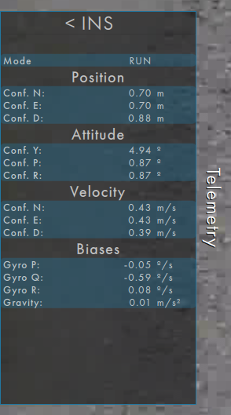

* Start mapping by typing *path start; path log* in the Putty window. When you’re done, stop the path log process by pressing CTRL+C, then type *path stop*.

## Focus Calibration

A calibration of focus versus range is used to focus the camera during operation. The calibration is different for each individual camera+lens combination and may drift over time. Therefore, a new calibration is needed if the camera or lens are replaced or if soft imagery is observed. Take the following steps to calibrate the focus:

* Download and install Allied Vision’s Vimba Viewer program from here:
  + <https://www.alliedvision.com/en/products/software.html>
* Ensure Jumbo Frames are available and set to the largest number of bytes for your Ethernet adaptor. This setting is available in Device Manager under Network Adaptors, Properties, Advanced as shown below:

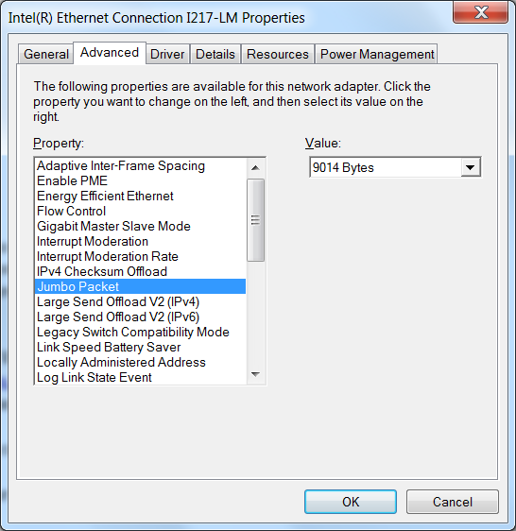

* Setup the gimbal so that the camera can view an object 10m to 30m away and objects at least 1 to 2 miles away. Using a tape measure, determine the distance from the camera to the close object with an accuracy of ±0.25m.
* Power up the gimbal and ensure your computer is connected to the AVT camera directly or using a GigE switch. Launch the Vimba Viewer and connect to the camera by selecting the camera as shown below:

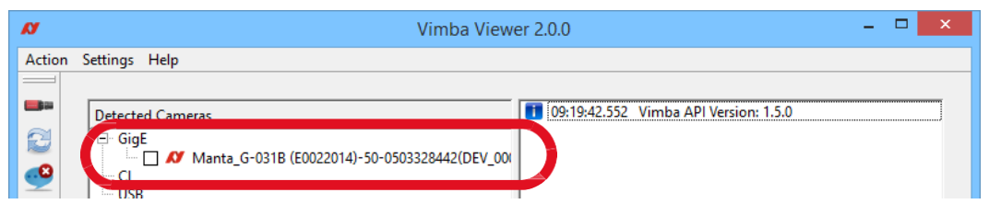

* Ensure the Trigger source is set to Freerun under the Trigger IO tab
* Start video by pressing the play button in the upper left corner.

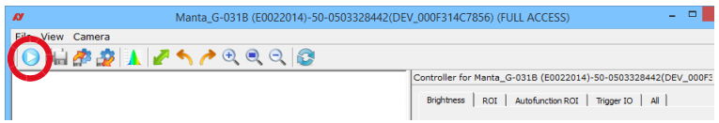

* Set the AGC to Auto Continuous (under the Brightness tab on the right).

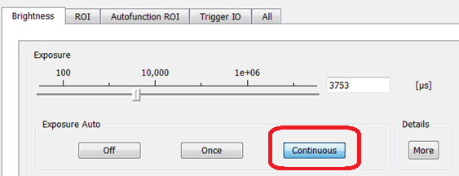

* Lens controls are under the All tab on the right under the Controls sub-tab; make sure the lens f/stop is set to its minimum by commanding 1, the camera will then default to the minimum f/stop.

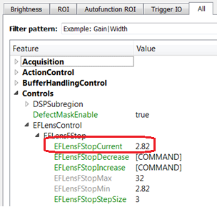

* Determine optimal focus on the close and far objects by typing in focus values in the lens focus interface. The focus should be determined within 5 counts. Note that the Vimba interface displays the previous focus command, not the current focus command, so ensure you record the commanded optimal focus, not necessarily what is displayed. In some cases, determining optimal focus is best done by averaging the two values where the focus starts to degrade. As an example, if focus starts to look poor at or below 700 counts and at or above 720 counts, then optimal focus would be 710 counts.

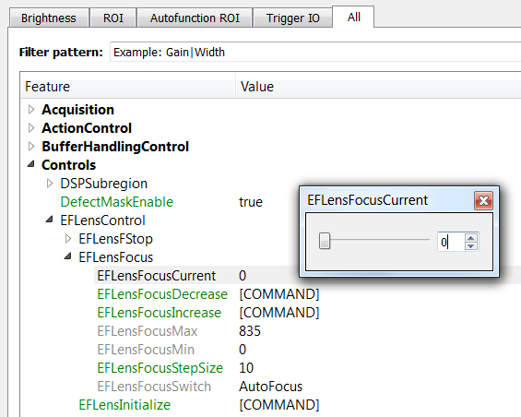

* Enter the close object distance and optimal focus for the close and far objects in the attached Focus Calibration spreadsheet. Record the Slope and Offset values for use in the Path Mapper Settings file as shown below.

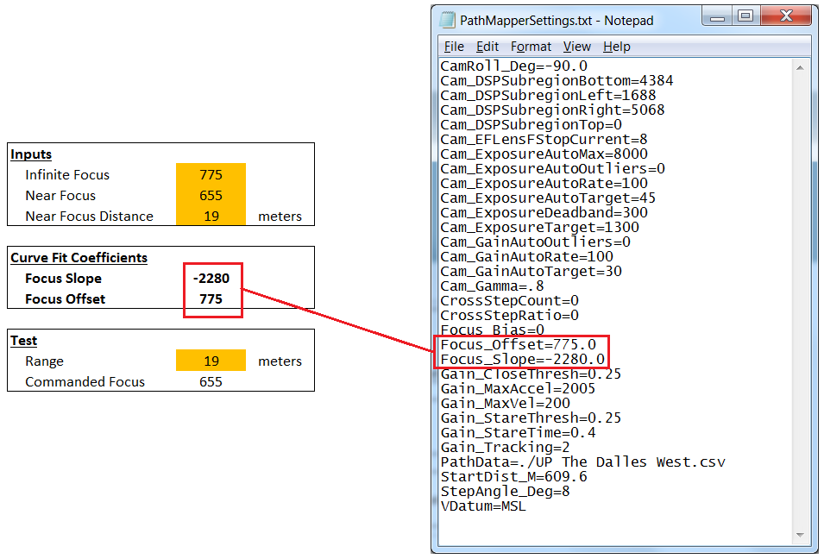

* Affix a label to the lens with the resulting coefficients

